Why did people own slaves in the 1800s?
Reasons ranging from political, social, & economic beliefs all build a society where in the minds of white Americans in southern states slavery was just another reality that seemed necessary, traditional, and even scientifically rationale.

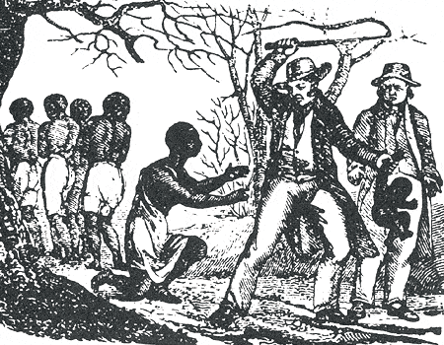

How could people support owning a fellow human being?
The question of whether it was morally right or wrong to own slaves never entered white slave owners’ minds since even in religious texts such as the bible slavery seemed justified.
Southern slaveholders often used biblical passages to justify slavery.
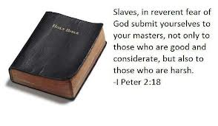
Defenders of slavery noted that in the Bible, Abraham had slaves. They point to the Ten Commandments, noting that "Thou shalt not covet thy neighbor's house, ... nor his manservant, nor his maidservant." In the New Testament, Paul returned a runaway slave, Philemon, to his master, and, although slavery was widespread throughout the Roman world, Jesus never spoke out against it.
Those who defended slavery rose to the challenge set forth by the Abolitionists. The defenders of slavery included economics, history, religion, legality, social good, and even humanitarianism, to further their arguments.
Defenders of slavery argued that the sudden end to the slave economy would have had a profound and killing economic impact in the South where reliance on slave labor was the foundation of their economy. The cotton economy would collapse. The tobacco crop would dry in the fields. Rice would cease being profitable. Without these vital crops what would happen to America’s wealth in international trade?
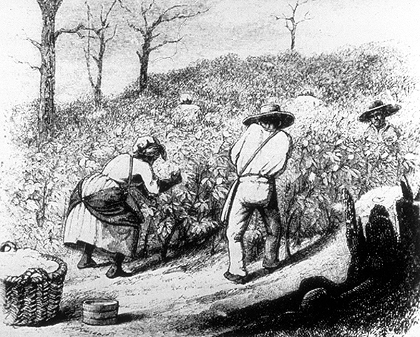
Defenders of slavery argued that if all the slaves were freed, there would be widespread unemployment and chaos. Such an unstable society would surely lead to violence.
What were Southerners afraid would happen if they let all of the slaves go free?
If slave owners let their slaves go, not only would they have no way to plant and harvest their crops, but also where would the slaves live? How would they find jobs? Most importantly would they want revenge on their formers masters? If no one would pay freed men to do the same jobs as before or if there were more former slaves than white people in small southern towns what could possibly go wrong? Southerners feared that if slaves were set free that this would lead to uprisings, bloodshed, and anarchy. They pointed out that mob's "rule of terror" during the French Revolution had peasants killing massive numbers of French aristocrats. In the minds of wealthy plantation owners things should remain status quo. After all why risk setting the world upside down? Slave labor was the most effective way to provide for the affluence and stability for the white slaveholding class and for all free people who enjoyed the bounty of the slave society.
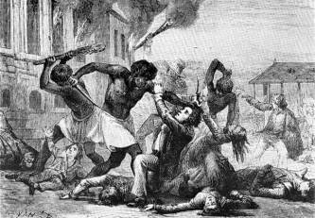

“This is the way it has always been. This is the way it will always be?”
Some slaveholders believed that African Americans were biologically inferior to their masters. During the 1800s, this argument was taken quite seriously, even in scientific circles.
Defenders of slavery argued that slavery had existed throughout history and was the natural state of mankind. The Greeks had slaves, the Romans had slaves, and the English had slavery until very recently.
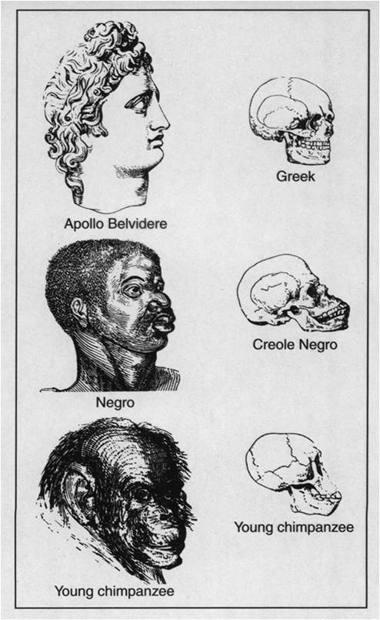
Slavery was, according to this argument, a good thing for the enslaved. John C. Calhoun said, "Never before has the black race of Central Africa, from the dawn of history to the present day, attained a condition so civilized and so improved, not only physically, but morally and intellectually." In other words slave owners believed that by providing for their slaves food, water, shelter, clothes, & medical treatment the benefits of what they were getting compensated for their lack of freedom Defenders of slavery argued that by comparison with the poor of Europe and the workers in the Northern states, that slaves were better cared for. They said that their owners would protect and assist them when they were sick and aged, unlike those who, once fired from their work, were left to fend helplessly for themselves. . In fact most slave owners would argue their slaves better factory owners treated their immigrants factory workers much more harshly. Poor immigrant laborers in the North worked in loud, dirty, and dangerous factories only being paid a pittance. Most worked 12 to 14 hour days and barely made enough to pay for food & rent if that. Factory workers were not offered any medical treatment if they got hurt on the job. Numerous deaths occurred in factories across the north on a regular basis even amongst the female and child laborers who had often times had the most dangerous jobs and were paid the least. Slavery by comparison seemed more humane to most white Southerners.
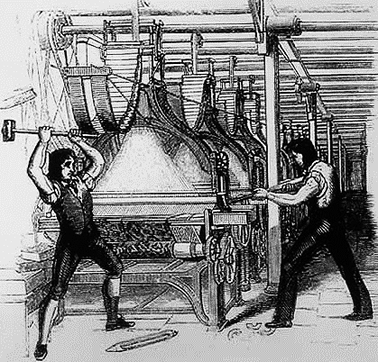
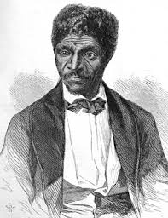
The Law of the Land
Some abolitionists would fight back and encourage slaves to run away using an intricate network of escape routes called the Underground Railroad. Other would use the American Legal system to fight for their freedom. Defenders of slavery turned to the courts, who had ruled, with the Dred Scott Decision, that all blacks — not just slaves — had no legal standing as persons in our courts — they were property, and the Constitution protected slave-holders' rights to their property. What this meant was not that all African Americans free or slave were not to be counted as citizens and therefore were not going to receive the same rights as white Americans nor were they even equal to the millions of European immigrants who poured into the country during the 1800s.

Directions:
I. Read and mark the text above.
II. Complete the tasks below:

- Identify 2-4 reasons why southerners’ would see the need for slavery as an institution in the south?

- How did religion play a part in supporting slavery as morally justified?

- How did history & science play a part in spreading both true and false information

- How did Dred Scott’s Supreme Court Case change the position for slaves & freed blacks in America?

- Create a thesis statement that would summarize southerners’ argument for slavery:

