Timeline of Your Life!

The purpose of this assignment is to illustrate how people and events shape our lives and our understanding of the world around us.

For this first project of the year students will create a timeline of their life, which will include:

- Their Full Name, Date and Place of Birth. (Names of their Parents/Guardians)
- Up to Six (6) personally significant events.
  - Event 1 –Birthday
  - Event 2 -One historically significant event from the year of their birth.
i.e. something that would make it to the newspapers or television news).
  - Event3 - Childhood
  - Event 4- Middle & High school
  - Event 5- High school
  - Event 6- This past summer of the current year.

- All events must include:
  - The date or year that it took place
    - All dates indicated on the timeline should be accurate and properly sequenced and LABELED WITH A TITLE.
  - A description of the event and the significance it holds in your life.
      - 2 Complete sentences please!
        - What Happened?
        - Why is it important?
        - How does this event still affect your life today?
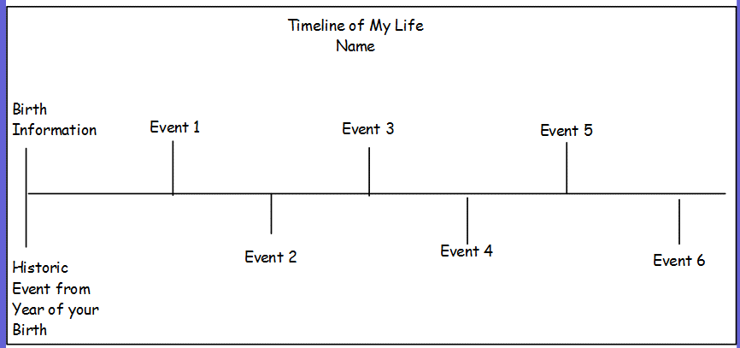

Q: How should the Timeline be structured?
A: Anyway you like! It can look like the example to the right or be creatively themed and organized.
- The timelines may be: hand drawn, painted, collaged, sculpted, and/or constructed of non-perishable (i.e. no food, or edible items). For other creative ideas please see teacher for approval. NO GLITTER PLEASE!

