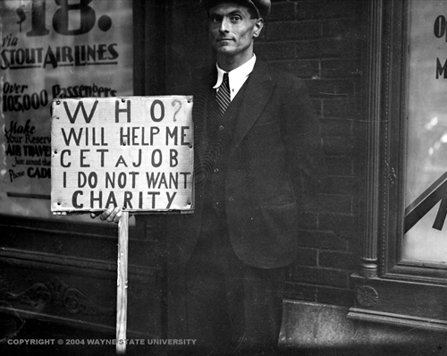
Unit 5 R.A.T Notes 2
The Stock Market Collapses

If individuals want to know whether they're getting ahead financially, they count the money in their pockets and in their bank accounts. But if one wants to know how the nation is doing, he looks at the Dow Jones Industrial Average (DJIA), and it gives an important clue as to whether investors feel confident or gloomy about the future. When the market keeps going up, is said to be a "bull" market, but when it continues to drop, it is a "bear" market. Sometimes, there is a correction, meaning that prices are a little too high, so it takes a short drop.

In the 1920s, many people invested in the market believing it would always go up. Stockbrokers (those who handle the sale of stocks) encouraged investment by selling stocks "on margin." A person could buy a stock by paying only 10% of its value. A $10 stock could be bought for one dollar. The broker put up the other nine dollars, but if this price dropped to say eight dollars, the buyer would have to put up the extra one dollar or the broker would sell the stock, and the buyer would lose his investment. As long as the prices of stock on the New York Stock Exchange were going up, people gave little thought to the risks.

Investors paid no attention to many warning signs that prosperity was fragile. The sorry state of the farm economy was one sign; many farmers could not make it and left their farms to take jobs in town. They were not buying farm equipment, which slowed down the farm implement business. Also, some Americans invested in the Florida land boom of the mid-1920s in the hope of making a fortune when someone wanted to buy the land from them at a fabulous profit. This was called the "Florida Bubble." However, in 1926 two hurricanes that hit Florida caused people to decide to invest elsewhere, and those who owned land there had to dump it for whatever price they could get. Those who had lost money were less inclined to gamble after that. Many Americans were too poor to buy radios, washing machines, and new cars; they did not add to the economy. Many people in the market thought it was too high, and they took their money out. With less people to buy stock, the market began to drop. Finally, big banks made many bad loans to nations with weak economies. That left them with little reserve when those countries defaulted (could not pay their debts).

The first signs of trouble came in September 1929, when the market dipped; but after it came up for a time, investors assumed it was just a correction. On October 23, major stocks dropped rapidly, but banks bought up stocks to keep a panic from occurring. On October 29, 1929, panic hit the market. Everyone wanted to sell stocks, and no one wanted to buy. Brokers called investors and told them to "put up more margin," but they could not begin to cover the losses, and more stocks were put up for sale.

The market steadied after that because no one could believe that the bull market was dead. From September 3 to the end of October, AT&T dropped $106 a share, General Electric by $228.13 a share, and RCA from $101 to $28 a share. Some companies could hardly sell this stock for any price.

Results: Many investors lost everything, including their money, their dreams, and their confidence.
Questions:

- What is a “bear" market? What is a "bull" market?
- When a correction occurs, what do investors assume?
- What does buying “on margin” mean?

- As a margin buyer who purchased 100 shares of a stock in 1925 at $50 a share, how much margin did you have to put up?
- What business was especially hurt because of the farmers' hard times?
- Why did people suddenly lose enthusiasm for buying land in Florida?
- Why did the collapse of the economies of nations like Bolivia and Germany hurt the big American banks?
- What held the market up on October 23 when it began to drop?
- Why didn't investors put up more margin on October 29?
- When you bought 100 shares of AT&T stock at its peak in September 1929, how much did you lose when you sold it at the close of October 29?

