YOUTH, MASS CULTURE, AND PROTEST: THE RISE AND IMPACT OF 1960S ANTIWAR MUSIC
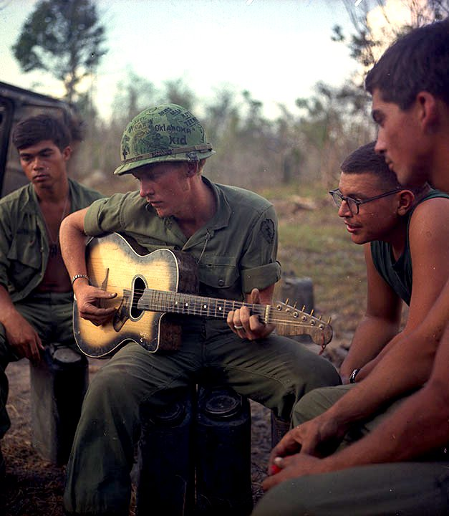
Essential Question: How did antiwar protest music provide a voice for those opposed to the Vietnam War?
Just as the United States has a long, complicated history of war and international conflict, so too has the nation seen resistance to that activity. During the 1960s, however, protest against war became a particularly visible part of American life. Television, a relatively new phenomenon, showed both graphic, often brutal images of the Vietnam War and footage of social and political unrest at home. In this period, protest music was among the most powerful means of voicing opposition to the United States’ involvement in the Vietnam War. Although protest music was not new — one finds rich examples of music calling for change in slave spirituals, labor songs, and even the popular songs produced on Tin Pan Alley during the first World War, for instance — it reached new heights in the 1960s, as many young Americans, facing mandatory participation in the war, grew increasingly outspoken in their dissent.
Prior to the antiwar demonstrations on and around college campuses, the Civil Rights movement in particular had increased student activism. As American involvement in Vietnam deepened, many in that age group faced the disconcerting reality of conscription. Even before they shipped out, those who were drafted had begun to see the horrors of the war, most notably on television. The growing presence of television in nearly every American household thus exacerbated divisions over the conflict and helped fuel the antiwar movement. What Americans watched on television each night shaped their perceptions of the Vietnam War, which came to be known as the “living room war.” For some young Americans, called on to fight but unable to vote until the age of 21, the situation was unacceptable.
Social protest provided young people with a voice they didn’t always have at the ballot box. Popular music, already a vital part of youth culture by the mid-1960s, became a vehicle through which they could hear their concerns put to music. The music helped to build the antiwar community. In earlier eras, protest music sometimes had a subtle tone, propelled by acoustic instruments. By the late 1960s, however, it took on the instrumentation of Rock and Roll and made its way to the top of the charts. Not until 1971 did the 26th Amendment grant suffrage to 18-year-olds, empowering those most directly affected by the military draft. With the war increasingly unpopular at home and no American victory in sight, the United States negotiated a peace treaty and withdrew from Vietnam in 1975. The music of 1960s protest, however, remained among the era’s most enduring legacies

American Studies: Vietnam War

The Vietnam War: Protest Music

Eve of Destruction:

- What does Barry McGuire mean when he says:
  - “You’re old enough to kill, but not for votin’”

  - “If the button is pushed there’s no runnin away”

- What is the overall message of this song?

Ballad of the Green Berets:

- How does this song make you feel?

- How does the song portray soldiers?

- Does this song support or condemn American Involvement of the Vietnam War?

- How do you know (give two specific examples from the song)?

Ohio:
1. Who are the soldiers Crosby, Stills, Nash, and Young are referring to? What
do you think the artists mean by “tin soldiers”? (Hint: Tin is a cheap metal.)

2. What event is this song written for? How do you know? (Use specific examples
from the lyrics.)

War:
1. What is the overall message of this song? Think about the tone as well as the
lyrics.

2. Choose 1-2 lines in the song that you feel send the strongest message. Record
them here:

Why did you choose those lines? What message do they send? What is especially
powerful about the lines you chose?

Sum it all up:
- Why do you think so much music was written about the Vietnam War?

- Why is music such an effective and powerful form of protest?

