Introduction
The Industrial Revolution, which took place from the 18th to 19th centuries, was a period during which predominantly agrarian, rural societies in Europe and America became industrial and urban. Prior to the Industrial Revolution, which began in Britain in the late 1700s, manufacturing was often done in people’s homes, using hand tools or basic machines. Industrialization marked a shift to powered, special-purpose machinery, factories and mass production. The iron and textile industries, along with the development of the steam engine, played central roles in the Industrial Revolution, which also saw improved systems of transportation, communication and banking. While industrialization brought about an increased volume and variety of manufactured goods and an improved standard of living for some, it also resulted in often grim employment and living conditions for the poor and working classes.

Britain: Birthplace of the Industrial Revolution
Before the advent of the Industrial Revolution, most people resided in small, rural communities where their daily existences revolved around farming. Life for the average person was difficult, as incomes were meager, and malnourishment and disease were common. People produced the bulk of their own food, clothing, furniture and tools. Most manufacturing was done in homes or small, rural shops, using hand tools or simple machines.
A number of factors contributed to Britain’s role as the birthplace of the Industrial Revolution. For one, it had great deposits of coal and iron ore, which proved essential for industrialization. Additionally, Britain was a politically stable society, as well as the world’s leading colonial power, which meant its colonies could serve as a source for raw materials, as well as a marketplace for manufactured goods.
As demand for British goods increased, merchants needed more cost-effective methods of production, which led to the rise of mechanization and the factory system

Innovation and Industrialization
The textile industry, in particular, was transformed by industrialization. Before mechanization and factories, textiles were made mainly in people’s homes (giving rise to the term cottage industry), with merchants often providing the raw materials and basic equipment, and then picking up the finished product. Workers set their own schedules under this system, which proved difficult for merchants to regulate and resulted in numerous inefficiencies. In the 1700s, a series of innovations led to ever-increasing productivity, while requiring less human energy.
Developments in the iron industry also played a central role in the Industrial Revolution. In the early 18th century, Englishman Abraham Darby (1678-1717) discovered a cheaper, easier method to produce cast iron, using a coke-fueled (as opposed to charcoal-fired) furnace. In the 1850s, British engineer Henry Bessemer (1813-1898) developed the first inexpensive process (now known as the Bessemer Process) for mass-producing steel. Both iron and steel became essential materials, used to make everything from appliances, tools and machines, to ships, buildings and infrastructure.
The steam engine was also integral to industrialization. In 1712, Englishman Thomas Newcomen (1664-1729) developed the first practical steam engine (which was used primarily to pump water out of mines). By the 1770s, Scottish inventor James Watt (1736-1819) had improved on Newcomen’s work, and the steam engine went on to power machinery, locomotives and ships during the Industrial Revolution.

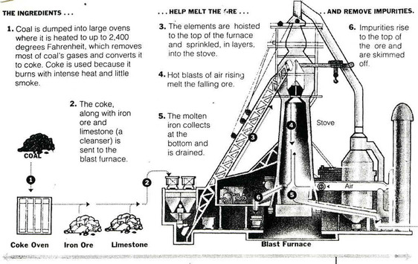

Transportation and the Industrial Revolution

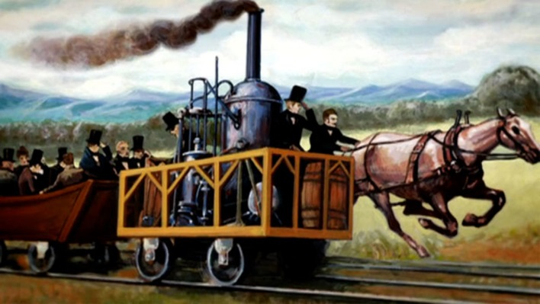
The transportation industry also underwent significant transformation during the Industrial Revolution. Before the advent of the steam engine, raw materials and finished goods were hauled and distributed via horse-drawn wagons, and by boats along canals and rivers. In the early 1800s, American Robert Fulton (1765-1815) built the first commercially successful steamboat, and by the mid-19th century, steamships were carrying freight across the Atlantic. As steam-powered ships were making their debut, the steam locomotive was also coming into use.
In the early 1800s, British engineer Richard Trevithick (1771-1833) constructed the first railway steam locomotive. In 1830, England’s Liverpool and Manchester Railway became the first to offer regular, timetabled passenger services. By 1850, Britain had more than 6,000 miles of railroad track. Additionally, around 1820, Scottish engineer John McAdam (1756-1836) developed a new process for road construction. His technique, which became known as macadam, resulted in roads that were smoother, more durable and less muddy.

Communication and Banking in the Industrial Revolution
Communication became easier during the Industrial Revolution with such inventions as the telegraph. In 1837, two Brits, William Cooke (1806-1879) and Charles Wheatstone (1802-1875), patented the first commercial electrical telegraph. By 1840, railways were a Cooke-Wheatstone system, and in 1866, a telegraph cable was successfully laid across the Atlantic.
The Industrial Revolution also saw the rise of banks and industrial financiers, as well as a factory system dependent on owners and managers. A stock exchange was established in London in the 1770s; the New York Stock Exchange was founded in the early 1790s. In 1776, Scottish social philosopher Adam Smith (1723-1790), who is regarded as the founder of modern economics, published “The Wealth of Nations.” In it, Smith promoted an economic system based on free enterprise, the private ownership of means of production, and lack of government interference.

Quality of Life during Industrialization
The Industrial Revolution brought about a greater volume and variety of factory-produced goods and raised the standard of living for many people, particularly for the middle and upper classes. However, life for the poor and working classes continued to be filled with challenges. Wages for those who labored in factories were low and working conditions could be dangerous and monotonous. Unskilled workers had little job security and were easily replaceable. Children were part of the labor force and often worked long hours and were used for such highly hazardous tasks as cleaning the machinery.
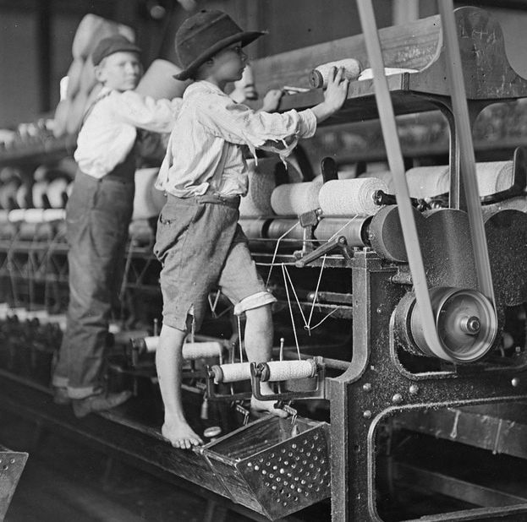
In the early 1860s, an estimated one-fifth of the workers in Britain’s textile industry were younger than 15. Industrialization also meant that some craftspeople were replaced by machines. Additionally, urban, industrialized areas were unable to keep pace with the flow of arriving workers from the countryside, resulting in inadequate, overcrowded housing and polluted, unsanitary living conditions in which disease was rampant. Conditions for Britain’s working-class began to gradually improve by the later part of the 19th century, as the government instituted various labor reforms and workers gained the right to form trade unions.

Industrialization Moves beyond Britain
The British enacted legislation to prohibit the export of their technology and skilled workers; however, they had little success in this regard. Industrialization spread from Britain to other European countries, including Belgium, France and Germany, and to the United States. By the mid-19th century, industrialization was well-established throughout the western part of Europe and America’s northeastern region. By the early 20th century, the U.S. had become the world’s leading industrial nation.

Economic Growth and the Early American Industrial Revolution
The transition from an agricultural to an INDUSTRIAL ECONOMY took more than a century in the United States, but that long development entered its first phase from the 1790s through the 1830s. The INDUSTRIAL REVOLUTION had begun in Britain during the mid-18th century, but the American colonies lagged far behind the mother country in part because the abundance of land and scarcity of labor in the New World reduced interest in expensive investments in machine production. Nevertheless, with the shift from hand-made to machine-made products a new era of human experience began where increased productivity created a much higher standard of living than had ever been known in the pre-industrial world.
The start of the American Industrial Revolution is often attributed to SAMUEL SLATER who opened the first industrial mill in the United States in 1790 with a design that borrowed heavily from a British model. Slater's pirated technology greatly increased the speed with which cotton thread could be spun into yarn. While he introduced a vital new technology to the United States, the economic takeoff of the Industrial Revolution required several other elements before it would transform American life.
Another key to the rapidly changing economy of the early Industrial Revolution were new organizational strategies to increase productivity. This had begun with the "OUTWORK SYSTEM" whereby small parts of a larger production process were carried out in numerous individual homes. This organizational reform was especially important for shoe and boot making. However, the chief organizational breakthrough of the Industrial Revolution was the "FACTORY SYSTEM" where work was performed on a large scale in a single centralized location. Among the early innovators of this approach were a group of businessmen known as the BOSTON ASSOCIATES who recruited thousands of New England farm girls to operate the machines in their new factories.
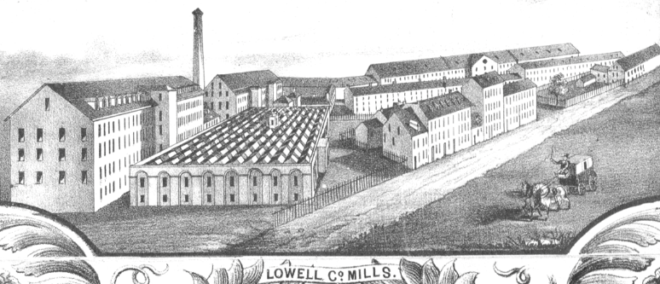
The most famous of their tightly controlled mill towns was LOWELL, MASSACHUSETTS, which opened in 1823. The use of female factory workers brought advantages to both employer and employee. The Boston Associates preferred female labor because they paid the young girls less than men. These female workers, often called "LOWELL GIRLS," benefited by experiencing a new kind of independence outside the traditional male-dominated family farm.
The rise of WAGE LABOR at the heart of the Industrial Revolution also exploited working people in new ways. The first strike among textile workers protesting wage and factory conditions occurred in 1824 and even the model mills of Lowell faced large STRIKES in the 1830s.
Dramatically increased production, like that in the New England's textile mills, were key parts of the Industrial Revolution, but required at least two more elements for widespread impact. First, an expanded system of credit was necessary to help entrepreneurs secure the capital needed for large-scale and risky new ventures. Second, an improved transportation system was crucial for RAW MATERIALS to reach the factories and manufactured goods to reach consumers. State governments played a key role encouraging both new banking institutions and a vastly increased transportation network. This latter development is often termed the MARKET REVOLUTION because of the central importance of creating more efficient ways to transport people, raw materials, and finished goods.
Alexander Hamilton's Bank of the United States received a special national charter from the U.S. Congress in 1791. It enjoyed great success, which led to the opening of BRANCH OFFICES in eight major cities by 1805. Although economically successful, a government-chartered national bank remained politically controversial. As a result, President Madison did not submit the bank's charter for renewal in 1811. The key legal and governmental support for economic development in the early 19th century ultimately came at the state, rather than the national, level. When the national bank closed, state governments responded by creating over 200 state-chartered banks within five years. Indeed, this rapid expansion of credit and the banks' often unregulated activities helped to exacerbate an ECONOMIC COLLAPSE IN 1819 that resulted in a six-year DEPRESSION. The dynamism of a capitalist economy creates rapid expansion that also comes with high risks that include regular periods of sharp economic downturns.
The use of a STATE CHARTER to provide special benefits for a PRIVATE CORPORATION was a crucial and controversial innovation in republican America. The idea of granting special privileges to certain individuals seemed to contradict the republican ideal of equality before the law. Even more than through rapidly expanded banking institutions, state support for internal transportation improvements lay at the heart of the nation's new political economy. Road, bridge, and especially canal building was an expensive venture, but most state politicians supported using government-granted legal privileges and funds to help create the INFRASTRUCTURE that would stimulate economic development.
The most famous state-led creation of the Market Revolution was undoubtedly New York's ERIE CANAL. Begun in 1817, the 364-mile man-made waterway flowed between Albany on the Hudson River and Buffalo on Lake Erie. The canal connected the eastern seaboard and the Old Northwest. The great success of the Erie Canal set off a canal frenzy that, along with the development of the steamboat, created a new and complete national water transportation network by 1840.

Cotton and African-American Life
The American Industrial Revolution, concentrated in the northeast, would ultimately prove to be the most significant force in the development of the modern United States. This economic innovation sprung primarily from necessity. New England's agricultural economy was the poorest in the country and that helped to spur experimentation there. Meanwhile, the far more fertile southern states remained fully committed to agriculture as the central source of its wealth, here, too, dramatic changes created a wholly new economy that would have been unrecognizable to late-18th century Americans.
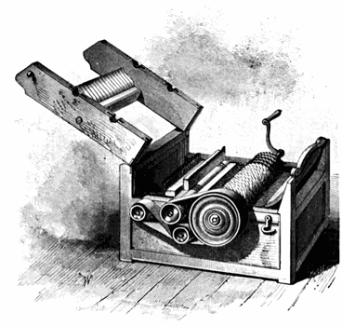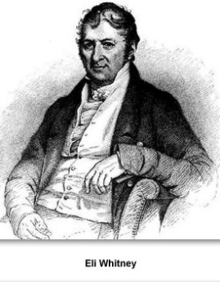
ELI WHITNEY was among the first to develop a COTTON GIN (short for "engine") that separated seeds from short-staple cotton. This hardier cotton variety thrived in the new land of the Old Southwest, and could now be processed far more efficiently than had been possible by hand. Indeed, the gin increased by fifty times what a single person could process in a day. This new cotton production, in turn, provided the raw material for the booming industrial textile mills of the American northeast and Great Britain. Technological innovation and geographic expansion made the south the world's largest producer and exporter of cotton in the 19th century.

This economic triumph, however, was accompanied by an immeasurable human tragedy. By 1820 all of the northern states outlawed slavery, but the rise of cotton made the enormous profits of the slave system irresistible to most white southerners. Distinctive northern and southern sections of the United States were emerging with the former more urban and industrial and the latter more agricultural, but the new economies of each section were deeply intertwined. Not only did southern cotton feed northern textile mills, but northern insurers and transporters played a major part in the growth of the modern slave economy of the cotton south.
Summary:

Bolded Terms Defined:

