How the Civil War Changed Your Life

8 things to think about as we mark the conflict's 150th anniversary
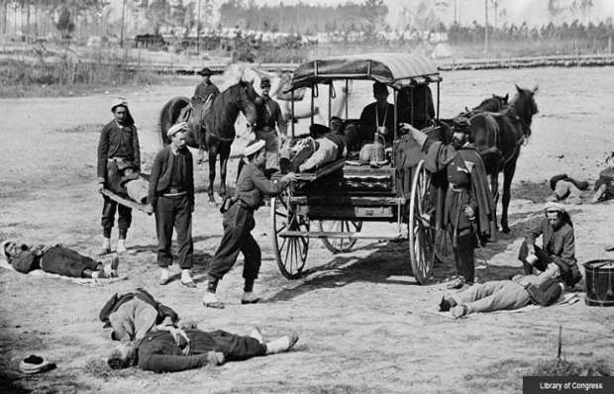
by Betsy Towner, April 12, 2011|

An ambulance crew demonstrates the removal of wounded soldiers from the field during the Civil War. — Library of Congress
Echoes of the nation’s greatest fight — the Civil War — still reverberate from coast to coast.
Some ring strong: of course the end of slavery, perhaps the worst disgrace in the nation's history. And the 620,000 ancestors lost. Other vestiges have weakened with the passage of time but are no less legacies of the four horrific, heroic years that shaped us as one nation.
Here are eight ways the Civil War indelibly changed us and how we live:
1. We have ambulances and hospitals.
The Civil War began during medieval medicine's last gasp and ended at the dawn of modern medicine. Each side entered the war with puny squads of physicians trained by textbook, if at all. Four years later, legions of field-tested doctors, well-versed in anatomy, anesthesia and surgical practice, were poised to make great medical leaps.
The nation's first ambulance corps, organized to rush wounded soldiers to battlefront hospitals and using wagons developed and deployed for that purpose, was created during the Civil War. The idea was to collect wounded soldiers from the field, take them to a dressing station and then transport them to the field hospital.
Doctors laid out the hospitals as camps divided into well-defined wards for specific activities such as surgery and convalescence. Women flocked to serve these hospitals as nurses.
Before the war, most people received health care at home. After the war, hospitals adapted from the battlefront model cropped up all over the country. The ambulance and nurses' corps became fixtures, with the Civil War's most famous nurse, Clara Barton, going on to establish the American Red Cross. Today's modern hospital is a direct descendant of these first medical centers.
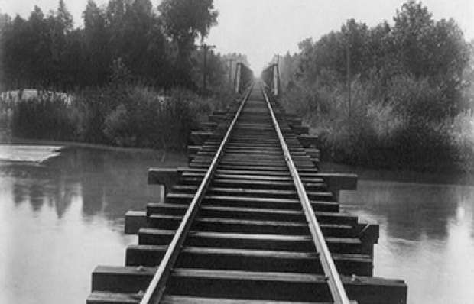
A view of the tracks at the Southern Pacific Railroad bridge over the Calloway Canal in Kern County, Calif.— Carleton Watkins/Library of Congress
2. We prize America as a land of opportunity.
The Civil War paved the way for Americans to live, learn and move about in ways that had seemed all but inconceivable just a few years earlier. With these doors of opportunity open, the United States experienced rapid economic growth. Immigrants also began seeing the fast-growing nation as a land of opportunity and began coming here in record numbers.
For many years Southern lawmakers had blocked the passage of land-grant legislation. But they weren't around after secession, and in 1862 Congress passed a series of land-grant measures that would forever change America's political, economic and physical landscape:
- The First Transcontinental Railroad. Also known as the "Pacific Railroad," the world's first transcontinental line, built between 1863 and 1869, was at least partly intended to bind California to the Union during the Civil War. To build the line, the Union Pacific and Central Pacific railroads were granted 400-foot rights-of-way plus 10 square miles of government-owned land for every mile of track built.
- Homesteading in the West. The Homestead Act, enacted in 1862, provided that any adult citizen (or intended citizen who had never borne arms against the U.S. government) could be granted 160 acres of surveyed government land after living on it — and making improvements to it — for five years. After the Civil War, Union soldiers could deduct the time they had served from the residency requirement.
- The land-grant college system. The Morrill Land Grant Act authorized the sale of public lands in every state to underwrite the establishment of colleges dedicated to the "agricultural and mechanical arts." It also required the teaching of military tactics. In time, the new law would give rise to such institutions of higher learning as Michigan State, Texas A&M and Virginia Tech.
The same year brought another innovation — a national paper currency — that would literally bankroll the rapidly expanding government and at the same time grease the wheels of commerce from coast to coast. In 1862, with the Union's expenses mounting, the government had no way to continue paying for the war. "Immediate action is of great importance," Treasury Secretary Salmon P. Chase told Congress. "The treasury is nearly empty." The solution: treasury notes bearing no interest and printed on the best banking paper, as proposed to President Abraham Lincoln by Col. Edmund D. Taylor, who would later became known as "the father of the greenback."

3. We begin summer with a tribute to fallen soldiers.
Ever wonder why we display flags and memorialize fallen solders just as summer gets under way? Flowers, that's why.
The first memorial days were group events organized in 1865 in both the South and North, by black and white, just a month after the war ended. Quickly evolving into an annual tradition, these "decoration days" were usually set for early summer, when the most flowers would be available to lay on headstones.
Decoration days helped the torn nation heal from its wounds. People told — and retold — their war stories, honored the feats of local heroes, reconciled with former foes.
After World War I, communities expanded the holiday to honor all who have died in military service, although the official national observance didn’t begin until 1971.
This year Memorial Day falls on May 30.
No matter where you are on Memorial Day, a national moment of remembrance takes place at 3 p.m. local time.
4. We let technology guide how we communicate.
Abraham Lincoln was a techie. A product of the Industrial Revolution, Lincoln is the only president to have held a patent (for a device to buoy boats over shoals). He was fascinated with the idea of applying technology to war: In 1861, for example, after being impressed by a demonstration of ideas for balloon reconnaissance, he established the Balloon Corps, which would soon begin floating hot-air balloons above Confederate camps in acts of aerial espionage.
Lincoln also encouraged the development of rapid-fire weapons to modernize combat. Pulitzer Prize-winning historian James McPherson, the author of Tried by War: Abraham Lincoln as Commander in Chief, notes that Lincoln personally tested the "coffee-mill gun," an early version of a hand-cranked machine gun.
But above all, Lincoln loved the telegram. Invented just a few decades earlier, the telegraph system had gone national in 1844.
As Tom Wheeler recounts in his book, Mr. Lincoln's T-Mails: The Untold Story of How Abraham Lincoln Used the Telegraph to Win the Civil War, the White House had no telegraph connection. Twice daily throughout his presidency, Lincoln walked to the telegraph office of the War Department (on the site of today's Eisenhower Executive Office Building, just west of the White House) to receive updates and to send orders to his generals on the front. He sent this one to General Ulysses S. Grant on Aug. 17, 1864: "Hold on with a bull-dog grip, and chew & choke, as much as possible."
Before Lincoln's day, letters and speeches were often long-winded. With the telegraph came the need for concise communication. After all, every dot and dash of Morse Code carried a cost. Gone were the "wherefores," "herewith" and "hences." Flowery, formal speech was out.
Lincoln's Gettysburg and Second Inaugural addresses both demonstrate this new economy of phrase. "Events were moving too fast for the more languid phrases of the past," historian Garry Wills writes in his book Lincoln at Gettysburg. "The trick, of course, was not simply to be brief but to say a great deal in the fewest words. Lincoln justly boasted, of his Second Inaugural's six hundred words, ‘Lots of wisdom in that document, I suspect.'"
Not only did Lincoln's wartime dependence on the telegraph eventually lead to a wave of investment in new communication devices, from the telephone to the Internet (the latter invented, not coincidentally, for military use), but it also signaled the evolution of a language that morphs as quickly as the devices that instantaneously tweet our words around the globe.
5. We identify ourselves as Democrats and Republicans.
Before 1854, you might have been a Whig. Or a Free Soiler. But that year the Republican Party was founded by anti-slavery activists and refugees from other political parties to fight the iron grip of powerful southern Democrats.
As the name of their party suggests, these activists believed that the republic's interests should take precedence over the states'. In the years before the war, many northern Democrats defected to join the new party — and, in 1860, to elect Abraham Lincoln as the first Republican president — while southern Democrats led the march to secession.
The Democratic and Republican parties both survived the war and have held their spots as the dominant U.S. political parties ever since. The "Solid South," as it was known, protected the interests of agrarian Southern whites and consistently elected Democrats to Congress from Reconstruction through the early 1960s, when the national Democratic Party's support of the civil rights movement allowed the Republican Party to begin making new political inroads below the Mason-Dixon Line.
Within a few years, North and South swapped party hats. Conservative southerners grew disenchanted with the Democratic Party's increasingly progressive platforms. Republicans capitalized on this with their "Southern Strategy," an organized plan to make headway there on a socially conservative, states' rights platform. In reverse, historically Republican strongholds in the Northeast began voting Democrat, establishing the pattern of red and blue that we see on election-night maps today.

This 1863 photograph shows a dead Confederate sharpshooter after the Battle of Gettysburg. — Alexander Gardner/Library of Congress
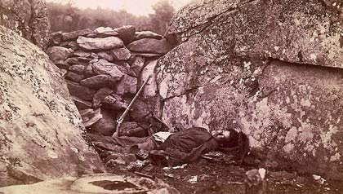
6. We see war "up close and personal."
The Civil War was the first war in which people at home could absorb battle news before the smoke cleared. Eyewitness accounts by reporters and soldiers were relayed via telegraph to the country's 2,500 newspapers, printed almost immediately and then read voraciously by citizens desperate to know how their boys were faring. The Civil War created a tradition of intimate war reportage that is still with us today.
Take this excerpt from a dispatch from George Townsend, who was just 20 when he began to cover the war for the New York Herald: "In many wounds the balls still remained, and the discolored flesh was swollen unnaturally. There were some who had been shot in the bowels, and now and then they were frightfully convulsed, breaking into shrieks and shouts. Some of them iterated a single word, as, 'doctor,' or 'help,' or 'God,' or 'oh!' commencing with a loud spasmodic cry, and continuing the same word till it died away in cadence. The act of calling seemed to lull the pain. Many were unconscious and lethargic, moving their finger, and lips mechanically, but never more to open their eyes upon the light; they were already going through the valley and the shadow."
Tony Horwitz, a former war correspondent and the author of Confederates in the Attic and the forthcoming Midnight Rising: John Brown and the Raid That Sparked the Civil War, says that the front-line dispatches influenced his modern battlefront reporting. "Having been moved by soldiers' writing from the 1860s, I also sought them on foreign battlefields, even going through the pockets of the Iranian dead at Majnoon and getting a Farsi speaker to translate letters and diaries for me," he says. "This sounds ghoulish, I know, but I think you need to personalize the dead to bring home the shock and tragedy of it all. Otherwise, they're just statistics."
Photography, still in its infancy, was not yet a part of the daily news cycle. But the Civil War was the first such conflict recorded by photographers (the most famous of whom was Mathew Brady). Because the primitive wet-plate technology of the era required that subjects be still at the moment the camera's shutter snapped, images of the era depict virtually every aspect of the war but one: battle. But that in time would change, too.
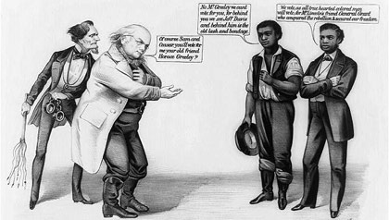
A political cartoon by Currier & Ives depicts Horace Greeley, the newspaper editor and anti-slavery activist, and Jefferson Davis, the leader of the Confederacy during the Civil War. — Currier & Ives/Library of Congress
7. We hold certain rights to be sacred.
Think of these three amendments to the U.S. Constitution, all ratified within five years of the end of the Civil War:
- 13th Amendment (1865).Section 1. Neither slavery nor involuntary servitude, except as a punishment for crime whereof the party shall have been duly convicted, shall exist within the United States, or any place subject to their jurisdiction. ...
- 14th Amendment (1868). Section 1. All persons born or naturalized in the United States, and subject to the jurisdiction thereof, are citizens of the United States and of the State wherein they reside. ...
- 15th Amendment (1870). Section 1. The right of citizens of the United States to vote shall not be denied or abridged by the United States or by any State on account of race, color, or previous condition of servitude. ...
Before the Civil War, the concept of liberty and justice for all meant little unless you were white and male. Going beyond the abolition of slavery, the 14th and 15th amendments were the first extensions of citizenship and voting rights to minority groups.
Of course, half of us — women — went without a voice until 1920, but the postwar laws set a precedent that eventually would lead to suffrage for all adults. Imperfect in practice over the next 100 years, voting rights finally gained protection through the 1964 Civil Rights Act, ensuring that bigotry could never again disenfranchise any U.S. citizen.
8. We're all Americans.
It took the War Between the States to make us one nation, indivisible. Before 1861, the United States were loosely tied entities and always described as a plural noun, as in, "The United States are in trade with France."
The war's bloodiest battle came at Gettysburg in 1863, with 51,000 casualties in just three days. Although the Union stopped Confederate Gen. Robert E. Lee's Northern invasion, young men's bodies littered the farms and gardens that had turned into a battleground. Was the preservation of these united states worth the cost in blood?
At a memorial for the dead, Lincoln intentionally called on the Union to persevere for a single national ideal: "[T]hat we here highly resolve that these dead shall not have died in vain — that this nation, under God, shall have a new birth of freedom — and that government of the people, by the people, for the people, shall not perish from the earth."
The effect of Lincoln's Gettysburg Address, just 272 words from beginning to end, was radical and immediate. "By accepting the Gettysburg Address, its concept of a single people dedicated to a proposition, we have been changed," Wills writes. "Because of it, we live in a different America."
But the shift was more than a statesman's creation. It was also forged in the experience of hunger, disease, blood and death shared for four years by the Union and Confederacy alike. Tellingly, the tradition of Civil War reenactments began even before the conflict had ended, as returning soldiers recreated battlefield scenes at home to educate the citizenry and pay tribute to their fallen comrades.
Ken and Ric Burns, in their introduction to the book The Civil War, write: "Some events so pervasively condition the life of a culture that they retain the power to fascinate permanently. They become the focus of myth and the anchor of meaning for a whole society."
The Civil War became our anchor. Ever since, whether big government or small government, whether doves or hawks, black or white, we have all been one thing: Americans.

How the Civil War Changed Your Life: 8 things to think about as we mark the conflict's 150th anniversary
After having read the article do the following tasks!
  - What is the Author’s thesis?

  - In a paragraph write a response to the author explaining where you agree or disagree with his claims.

  - Please come up with your own list of ways the civil war has changed (or affected ) your life in contemporary American society.

